I B. Tech I Semester Regular/Supplementary Examinations – February,2024
SEMICONDUCTOR PHYSICS & ELECTROMAGNETICS
(CSE(DS)/CSE(AIML)/EEE)
1 (a) State Biot-savarts law and explain in detail [3M]
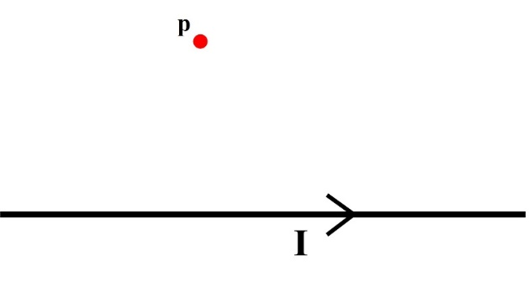
(b) Derive an expression for magnetic field at point ‘P’ (at a perpendicular distance) of a current conducting wire of finite length as shown in the figure. [5M]

(c) What is the direction of magnetic field in the above problem at point ‘P’. [2M]
2 (a) Write the physical significance of wavefunction (ψ)? [2M]
(b) Derive an expression for eigen function and energy eigen values of a particle struck in a one-dimensional infinite potential well of width ‘a’. [5M]
(c) An electron is confined within an infinite potential well of width a = 5 nm. Calculate the energy of emitted photon when an electron jumps from the first excited state to ground state. [3M]
3.(a) Distinguish between direct bandgap and indirect bandgap semiconductors? [3M]
(b) Explain the design aspects of Light-Emitting Diodes (LEDs), highlighting their construction and operational mechanisms? [4M]
(c) A LED emits light with a wavelength of 620 nm in the red region. Calculate the energy associated with each photon emitted by this LED. [3M]

4. (a) Outline the important characteristic features of a laser? [2M]
(b) Compare the processes of stimulated and spontaneous emissions and explain in detail?
[3M]
(c) How does population inversion contribute to the fundamental operation of a laser system, and what role does it play in the generation of coherent light through stimulated emission?
[2M]
(d) A laser emits light with an energy of 3×10⁻¹⁹ J per photon. If this laser produces 2×10¹⁶ photons per second, calculate the power and emission wavelength of this laser. [3M]

SECTION - B
Answer all Two questions 2×20M=40M
5. (a) How would you formulate the expression for electrical conductivity in metals by applying the principles of the free electron theory? [5M]
(b) A uniform silver wire has a resistivity of 1.54×10⁻⁸ Ωm at room temperature. an electric field of 1 volt cm^{–1} is applied along the wire. Compute the mobility and average drift velocity of electron assuming that there are 5.8 × 10²⁸ conduction electrons /m³. [5M]
(c) What is the fermi-dirac distribution function, and how does it vary with temperature?
[5M]
(d) Using fermi distribution function obtain the value of F(E) at 100 K for a level with energy 0.01 eV above the fermi energy level. [5M]

6. (a) Explain the Hall effect and derive an expression for hall voltage? [6M]
(b) A semiconductor material experiences a magnetic field of 0.5 T perpendicular to a current flowing through it at 20 mA. If the width of the semiconductor sample is 2 mm and a Hall voltage of 5 mV is measured across it, calculate the charge carrier density of the semiconductor. [4M]
(c) Define numerical aperture and acceptance angle? Obtain the mathematical equations to evaluate the acceptance angle and numerical aperture of an optical fiber. [5M]
(d) An optical fiber with a core refractive index of 1.48 is surrounded by a cladding material with a refractive index of 1.46. Determine the numerical aperture and acceptance angle for light traveling through this fiber. [5M]

